**Initial Implementation Screenshots**

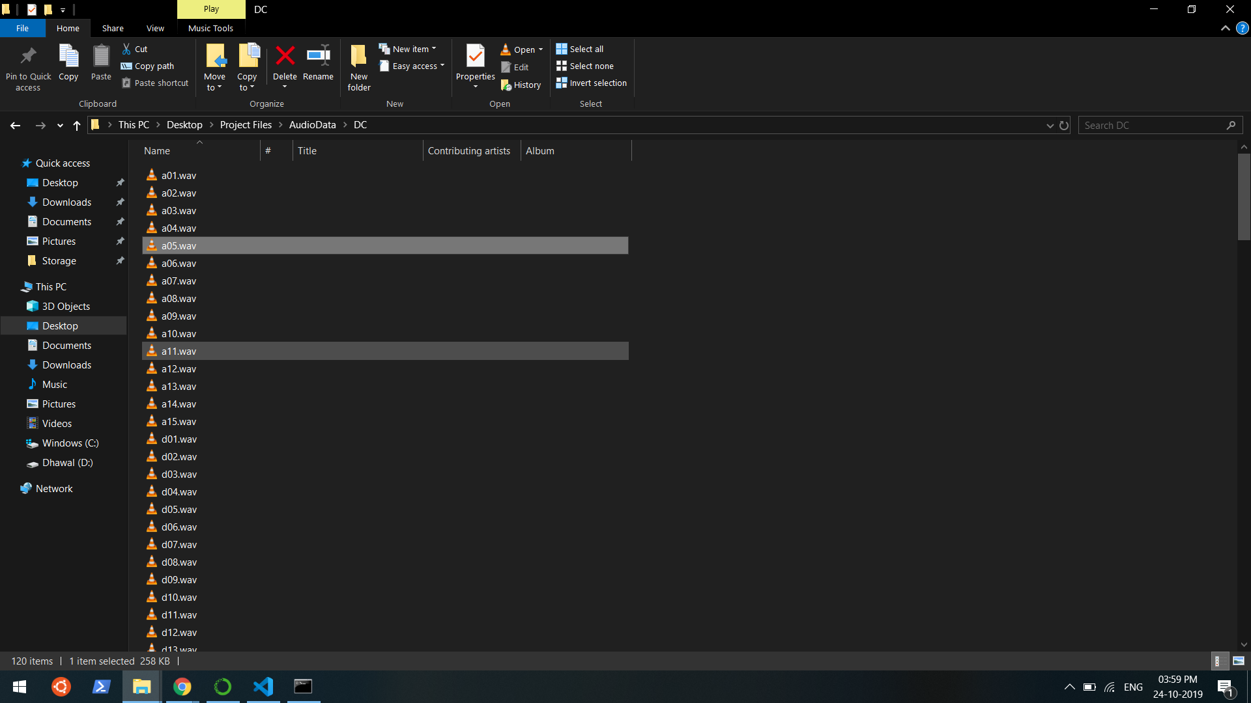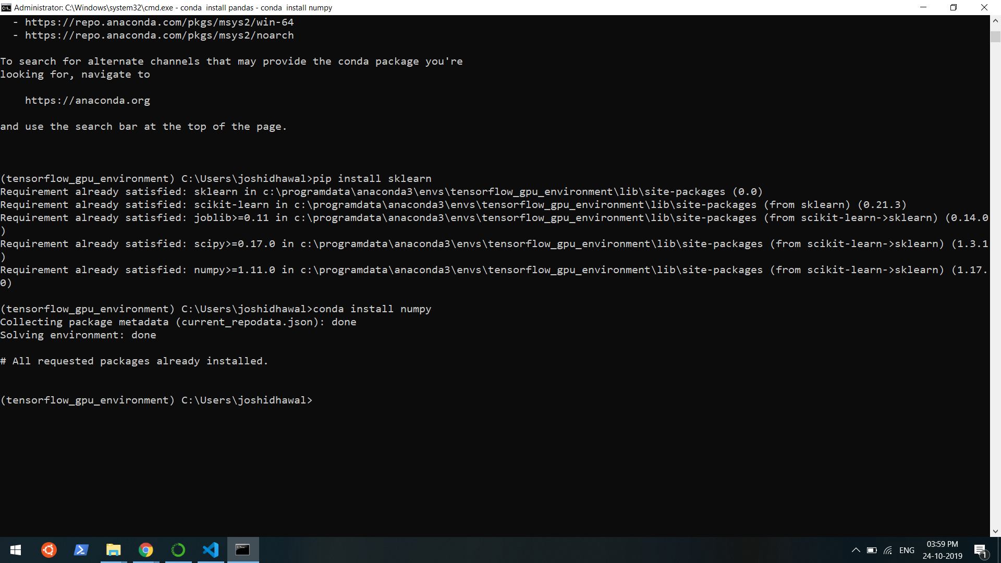Fig 1 : Installation of Required Software and Libraries

Fig 2 : Data Cleaned, Formatted and Ready to be used

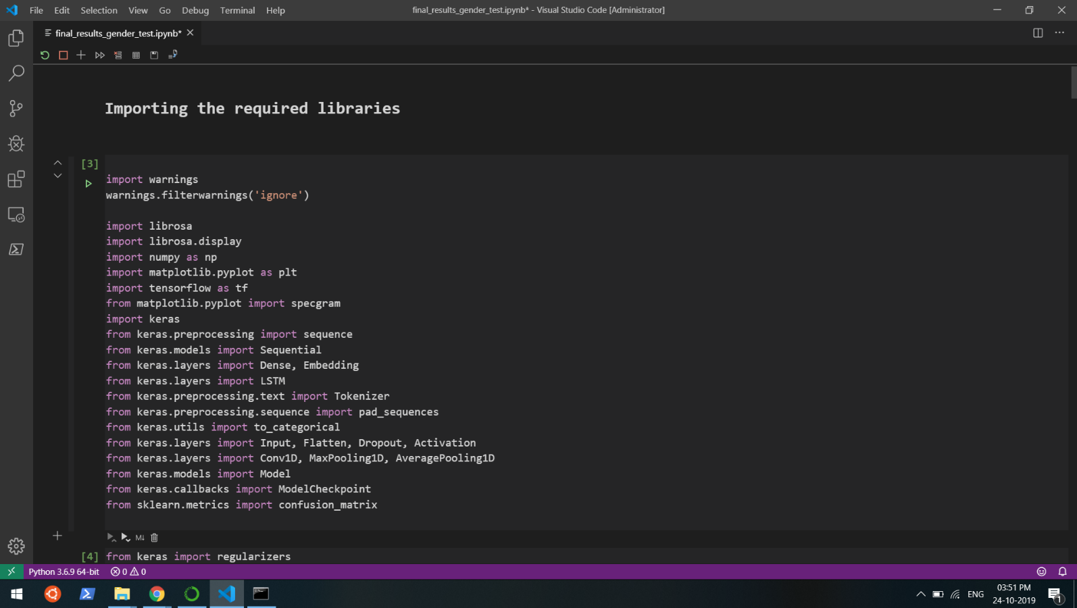

Fig 3 : Importing the Required Libraries into the Jupyter Notebook

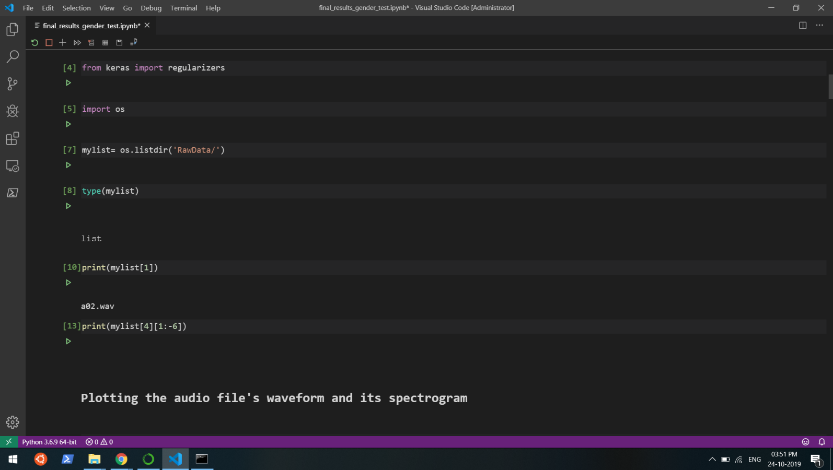

Fig 4 : Importing the Data into the Jupyter Notebook

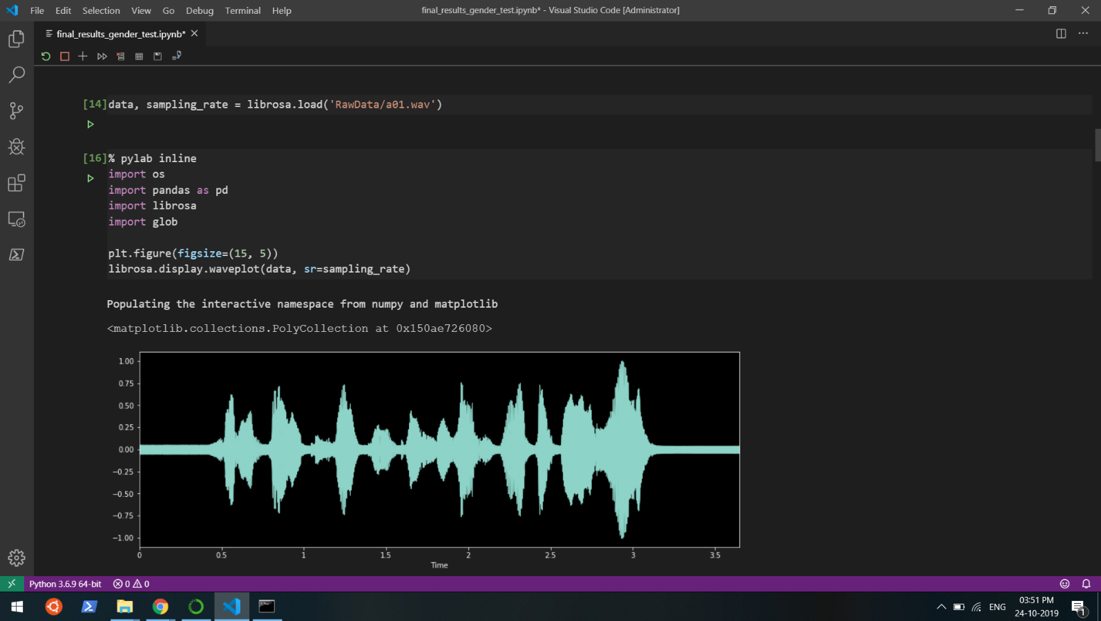

Fig 5 : Visualizing the Data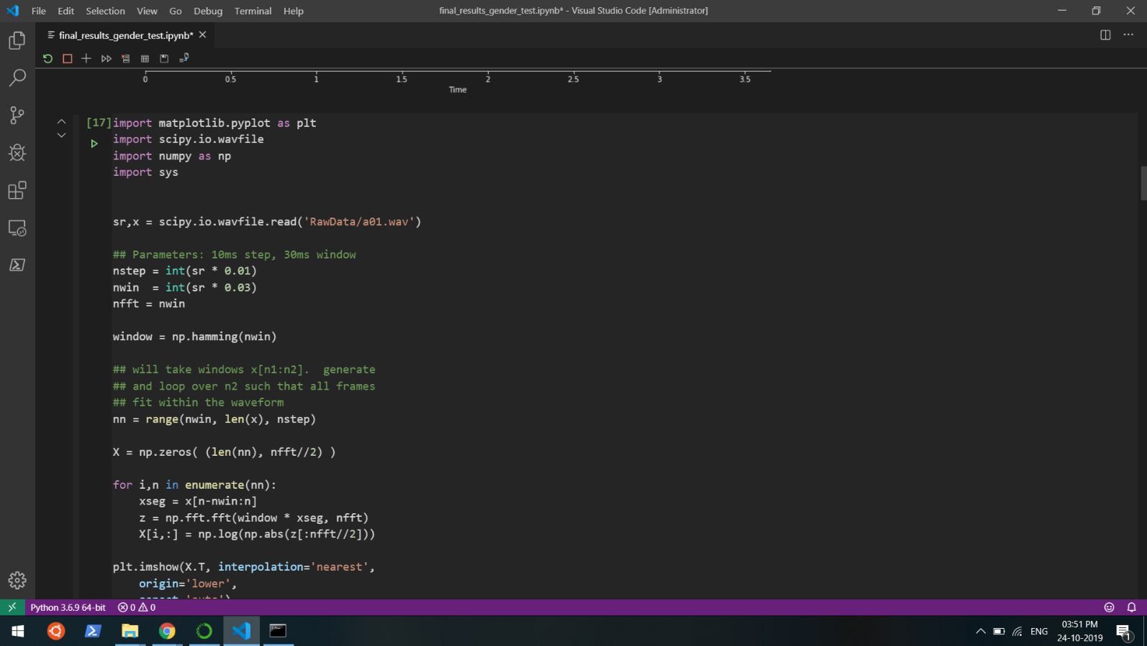

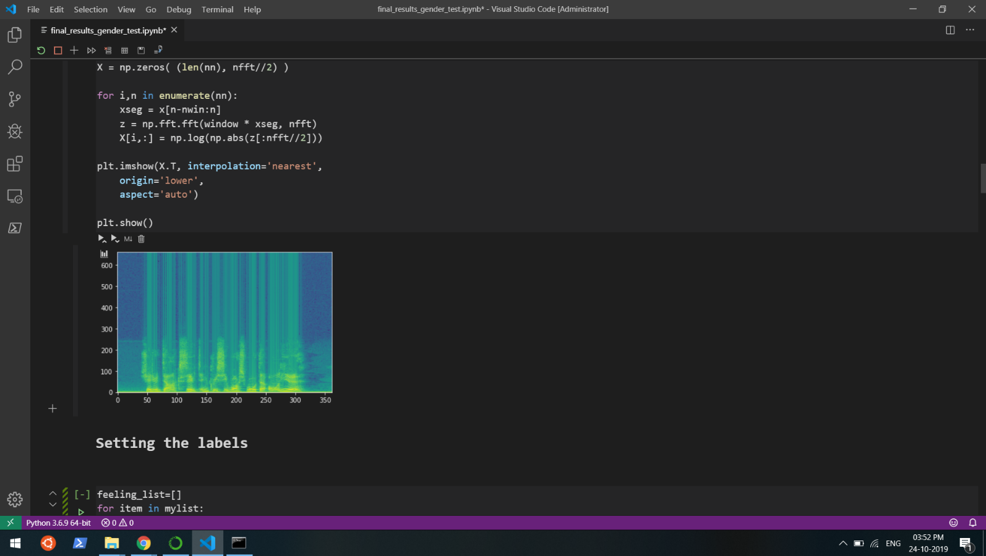

Fig 6 and 7 : Plotting the data and visualising it to understand it.